CLOUDZENIA DEMO PROJECT

Summary -
This project demonstrates real-world AWS infrastructure provisioning using Terraform, following DevOps and production best practices.
Two different infrastructures were implemented
- ECS with ALB, RDS and Secrets Manager
- EC2 Instance with Domain Mapping and NGINX
The entire setup was created using modular Terraform code to ensure reusability and easy management.
I focused not only on creating resources, but also on making the architecture secure, scalable, automated, and close to real production environments.
Task-1 – ECS with ALB, RDS & Secrets Manager
This architecture was designed and provisioned using Terraform with high availability, scalability, and security in mind.
1. Network VPC for isolate the infrastructure
- A custom VPC with CIDR block 10.0.0.0/16 was created to isolate the infrastructure.
- The VPC was divided into
  - 2 Public Subnets
  - 2 Private Subnets
distributed across two Availability Zones for fault tolerance and high availability.
- An Internet Gateway (IGW) was attached to the VPC to provide internet access for public resources.
- A NAT Gateway was deployed in a public subnet to allow private resources to access the internet securely without being exposed.
2. Traffic Flow
- An Application Load Balancer (ALB) was created in the public subnets.
- The ALB uses host-based routing rules to forward traffic to ECS services
  - wordpress.<domain> → WordPress ECS service
  - microservice.<domain> → NodeJS ECS microservice
3. Container & Application Architecture
- An Amazon ECS Cluster was created using AWS Fargate.
- Two ECS services were deployed
  - WordPress Service
  - Custom NodeJS Microservice responding with “Hello from Microservice”
- An Amazon ECR repository was created to store the Docker image for the NodeJS microservice.
4. Database Architecture
- A MySQL RDS instance was provisioned inside the private subnets.
- Automated backups were enabled for data protection and disaster recovery.
5. Security & Secrets Management
- AWS Secrets Manager was used to store WordPress database credentials securely.
- ECS retrieves database credentials dynamically through IAM roles without hardcoding them.
- This improves security and follows best practices for secret management.
6. DNS & SSL Configuration
- Amazon Route 53 manages DNS records for
- wordpress.<domain>
- microservice.<domain>
- AWS ACM was used to create SSL certificates.
- All traffic is forced to use HTTPS by redirecting HTTP → HTTPS.
7. IAM Roles and Policies
- Two IAM roles were created
- ECS Task Role
- ECS Task Execution Role
- These roles allow ECS tasks to
- Pull Docker images from ECR
- Access secrets from Secrets Manager
- All permissions follow the principle of least privilege.

Task-2 – EC2 Instance with Domain Mapping & NGINX
This task extends the same infrastructure by reusing existing components instead of creating new ones.
1. Infrastructure Reuse
Instead of duplicating resources, these from Task-1 were reused
- VPC (10.0.0.0/16)
- Public and Private Subnets
- Internet Gateway
- NAT Gateway
- Application Load Balancer
- Route 53 Hosted Zone
- ACM SSL Certificate
- Route Tables and Security Groups
2. Network Workflow
- The same VPC and subnets were reused.
- The ALB remains in public subnets.
- EC2 instances are located in private subnets.
- NAT Gateway allows EC2 to install packages and pull Docker images securely.
3. EC2 Compute Plan
- Two EC2 instances were deployed in private subnets
  - Private-EC2-1
  - Private-EC2-2
- These instances do not have public IPs.
- Access is only through
  - Existing ALB for web traffic
  - Bastion server (if administrative access is required)
4. Application & Container Deployment
- Using user_data, each EC2 instance installs
  - NGINX
  - Docker
- A Docker container is deployed using hashicorp/http-echo.
- Container response
Namaste from Container
- NGINX works as a reverse proxy and web server.
Domain behavior

5. ALB & SSL Reuse
- The same ALB from Task-1 is reused.
- It handles traffic for both ECS and EC2 workloads.
- The same ACM SSL certificate was reused.
- HTTP traffic is redirected to HTTPS.
6. Target Groups
- Two target groups were created
  - One for EC2 Instance 1
  - One for EC2 Instance 2
- Each instance is attached only to its own target group.
- This ensures fixed routing
  - ec2-instance1 & ec2-docker1 → EC2 Instance 1
  - ec2-instance2 & ec2-docker2 → EC2 Instance 2
7. ALB Listener Rules
New host-based rules were added
- ec2-instance1 → Target Group EC2-1
- ec2-docker1 → Target Group EC2-1
- ec2-instance2 → Target Group EC2-2
- ec2-docker2 → Target Group EC2-2
8. DNS Setup
Route 53 records were created using the same hosted zone
- ec2-instance1.rameshmandigowdas.com
- ec2-docker1.rameshmandigowdas.com
- ec2-instance2.rameshmandigowdas.com
- ec2-docker2.rameshmandigowdas.com
All of them point to the existing ALB using Alias records.
9. Security Design
- EC2 instances remain private.
- Only ALB can access EC2 on port 80.
- SSL is terminated at the ALB.
- Docker and NGINX listen only on internal interfaces.
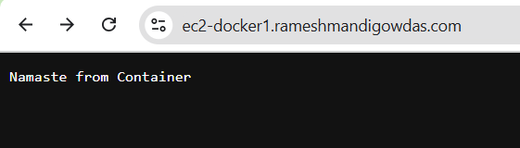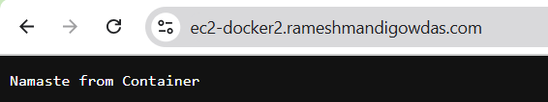
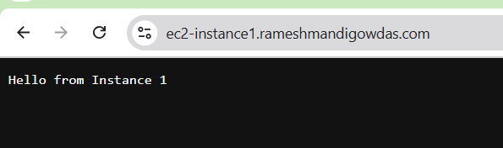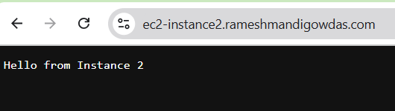

Task-3 – Observability for EC2 Instances
For monitoring and observability, AWS CloudWatch was implemented on both EC2 instances.
By default, AWS does not provide RAM utilization metrics. To overcome this limitation, I installed and configured the CloudWatch Agent on both instances.
A configuration file was created at
/opt/aws/amazon-cloudwatch-agent/bin/config.json
This file enables
- Memory (RAM) utilization monitoring
- NGINX access log forwarding
The agent was started with
sudo /opt/aws/amazon-cloudwatch-agent/bin/amazon-cloudwatch-agent-ctl \
-a fetch-config -m ec2 \
-c file/opt/aws/amazon-cloudwatch-agent/bin/config.json -s
After configuration
- RAM utilization metrics (mem_used_percent) are published to CloudWatch under the CWAgent namespace.
- NGINX access logs from /var/log/nginx/access.log are continuously sent to CloudWatch Logs.
When changes are required, the agent is restarted using
sudo /opt/aws/amazon-cloudwatch-agent/bin/amazon-cloudwatch-agent-ctl -a stop
sudo /opt/aws/amazon-cloudwatch-agent/bin/amazon-cloudwatch-agent-ctl -a start -m ec2 \
-c file/opt/aws/amazon-cloudwatch-agent/bin/config.json

CloudWatch Alarms
CloudWatch alarms were created using Terraform for both EC2 instances.
These alarms monitor
- CPU Utilization (> 70%)
- RAM Utilization (> 80%)
- Instance Status Check failures
If any of these thresholds are breached, an alarm is triggered.
CloudWatch Dashboard
A custom CloudWatch dashboard was created using Terraform to display
- CPU utilization
- Memory utilization
for both EC2 instances in a single consolidated view.
This provides a real-time operational overview of server health.

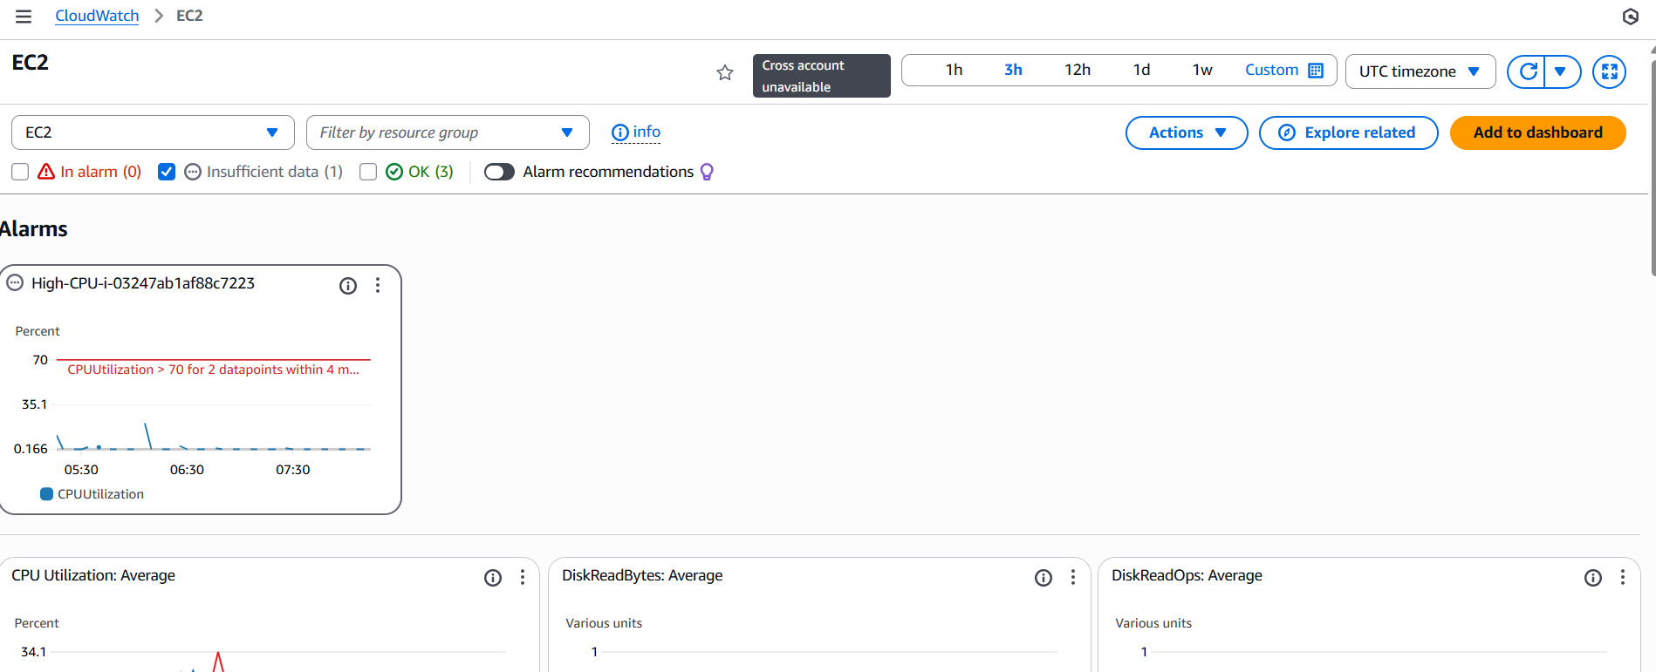

Task-4 – CI/CD Pipeline with GitHub Actions for ECS Deployment
This task focuses on implementing a complete CI/CD pipeline using GitHub Actions, allowing automated build, push, and deployment of a custom microservice to AWS ECS. The objective is to ensure continuous integration, seamless delivery, and zero-downtime updates.
1. Source Code Management
- The custom Node.js microservice was stored in a dedicated GitHub repository.
- The repository contains.
  - Source code (index.js, package.json)
  - Dockerfile for container packaging
  - GitHub Actions workflow under .github/workflows/deploy.yml
2. Docker Image Packaging
- A Dockerfile was created to containerize the application.
- The Dockerfile includes.
  - Base Node.js image
  - Copy application files
  - Install dependencies
  - Start the Express server
- The container exposes port 3000 and returns "Hello from Microservice".
3. GitHub Actions Workflow
A GitHub Actions workflow was configured to automatically.
- Trigger on.
  - Push to the main branch
  - Manual dispatch (optional)
- Authenticate with AWS using IAM OIDC provider.
- Build the Docker image inside GitHub runners.
- Tag the image with.
  - Latest version
  - Git commit SHA
- Push the Docker image to Amazon ECR.
- Update the ECS task definition with the new image.
- Force a new ECS deployment to ensure seamless rollout.
CI/CD Pipeline Flow
- Developer pushes code to GitHub →
- GitHub Actions builds image →
- Pushes to ECR →
- Updates ECS →
- ECS pulls image →
- ALB forwards traffic →
- Zero-downtime deployment achieved.
4. Secrets & Security
GitHub repository secrets store.
- AWS_ACCESS_KEY_ID
- AWS_SECRET_ACCESS_KEY
- AWS_REGION
- ECR_REPOSITORY
- ECS_SERVICE_NAME
- ECS_CLUSTER_NAME

Task-5 – S3 Static Website Hosting with CloudFront (Optional Enhancement)
This task provides a globally distributed, highly available static website using Amazon S3 combined with CloudFront. Optional advanced features include geo-restriction and Lambda@Edge.

1. S3 Static Website Hosting
- A dedicated S3 bucket was created with the name.
- static-s3.<domain-name>
- The bucket was configured for static website hosting, serving.
  - index.html
  - error.html
- Public access block was disabled only for website content via bucket policy.
2. CloudFront CDN Integration
A CloudFront distribution was created with.
- Origin. S3 bucket (website endpoint)
- Default cache behavior.
  - GET/HEAD allowed
  - Automatic compression enabled
- SSL certificate from ACM (region. us-east-1)
- Custom CNAME.
- static-s3.<domain-name>
- HTTP → HTTPS redirection enabled at CloudFront level.
CloudFront ensures.
- Low latency
- High global availability
- Caching for reduced load

3. Geo-Restriction
- CloudFront "Geographic Restrictions" were enabled.
- Specific countries were blocked (e.g., Russia, China, North Korea).
- When users from restricted countries attempt access, CloudFront returns 403 Forbidden.
4. Lambda@Edge (Optional)
A small Lambda@Edge function was attached to the CloudFront distribution to modify HTTP headers.
Purpose.
- Improve SEO by adding custom headers.
  - X-SEO-Region
  - X-Content-Type-Options
- Add security headers.
  - Strict-Transport-Security
  - X-Frame-Options
- Remove unnecessary headers to reduce exposure.
  - Server
  - X-Powered-By
The function executes on viewer response, ensuring minimal latency.
5. DNS Configuration
Route 53 was configured with an Alias A-record.
static-s3.<domain-name> → CloudFront Distribution
This allows the site to be served via friendly domain names instead of long CloudFront URLs.

